TRAFFIC MONITERING SYSTEM

**DEVELOPMENT PART-2**

**PHASE -4 :DOCUMENT SUBMISSION**

To develop the web and android application for displays the displays real-time restroom availability and cleanliness data.

**WEB DEVELOPMENT USING HTML CODE:**

**HTML CODE:**

<!DOCTYPE *html*>

<html>

<head>

        <title>traffic monitering system</title>

  <link *rel*="stylesheet" *href*="style.css">

</head>

<body>

    <h1><font *color*="blue"><center><a *href*=></a>TRAFFIC MONITERING SYSTEM</a></center></font></h1>

    <center><img *src*="https://urbanupdate.in/wp-content/uploads/2019/07/E5ccmfalj3QPUk-TBkulPkzn2ztS8lOqJZGHlf_oBQ8-1280x960.jpg"*width*="600"*height*="400"></center>

  <script *src*="script.js"></script>

</body>

</html>

<!DOCTYPE *html*>

<html>

<head>

<title>Page Title</title>

</head>

<body>

<h1>Need of traffic monitering system</h1>

<P>traffic monitering refers to the use of technology to improve the management and efficiency of parking spaces. This can include features like sensors to detect available parking spots, mobile apps to help users find parking, and data analytics to optimize parking operations. It can reduce congestion, save time for drivers, and improve the utilization of parking facilities</P>

<center><h2><font *color*="green">OUR TEAM MEMBERS ARE</font></h2></center>

<li>kalaivani(TEAM HEAD)</li>

        <li>preethika</li>

        <li>suganya</li>

        <li>vignesh</li>

        <li>nirenthiren</li>

        <li>subash</li>

<head>

<style>

  .increased-font{font-size: :20px;}

</style>

</head>

<body><strong><h2><font *color*="blue">For example</font></h2></strong>

Traffic monitering refers to the use of technology to improve the management and efficiency of parking spaces. This can include features like sensors to detect available parking spots, mobile apps to help users find parking, and data analytics to optimize parking operations. It can reduce congestion, save time for drivers, and improve the utilization of parking facilities.

   <img *src*="https://www.anabon.com/wp-content/uploads/2023/08/smart-restroom-2-copy.webp"*width*="600"*height*="400">

<body>

   <!DOCTYPE *html*>

<html>

<head>

<style>

table {

  font-family: arial, sans-serif;

  border-collapse: collapse;

  width: 100%;

}

td, th {

  border: 1px solid #dddddd;

  text-align: left;

  padding: 8px;

}

tr:nth-child(even) {

  background-color: #dddddd;

}

</style>

</head>

<body>

<center><h2><font *color*="green">ROOMS AVAILABILITY TABLE</font></h2></center>

<table>

  <tr>

    <th>AREA</th>

    <th>NO.OF ROOMS</th>

    <th>ROOMS AVAILABILITY</th>

  </tr>

  <tr>

    <td>CITY-1</td>

    <td>20</td>

    <td>15</td>

  </tr>

  <tr>

    <td>CITY-2</td>

    <td>12</td>

    <td>10</td>

  </tr>

  <tr>

    <td>CITY-3</td>

    <td>18</td>

    <td>15</td>

  </tr>

  <tr>

    <td>CITY-4</td>

    <td>23</td>

    <td>20</td>

  </tr>

  <tr>

    <td>CITY-5</td>

    <td>28</td>

    <td>20</td>

  </tr>

  <tr>

    <td>CITY-6</td>

    <td>15</td>

    <td>12</td>

  </tr>

</table>

</body>

</html>

</body>

</html>

**ABSTRACT:**

* The traffic monitoring system employing traffic flow sensors represents an innovative approach to urban management. This system relies on strategically placed sensors to collect real-time data on vehicular movement, enabling precise analysis of traffic patterns.

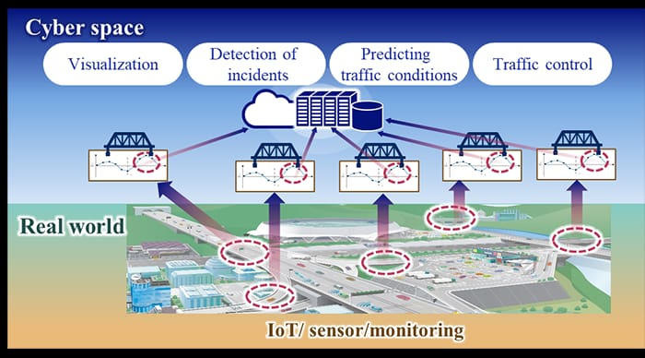

**OBJECTIVE:**

* Real-time data on vehicle movement.
* Congestion.
* Flow to optimize traffic flow.
* Improve safety.
* Infrastructure development.

**COMPONENTS OF TRAFFIC MONITORING SYSTEM:**

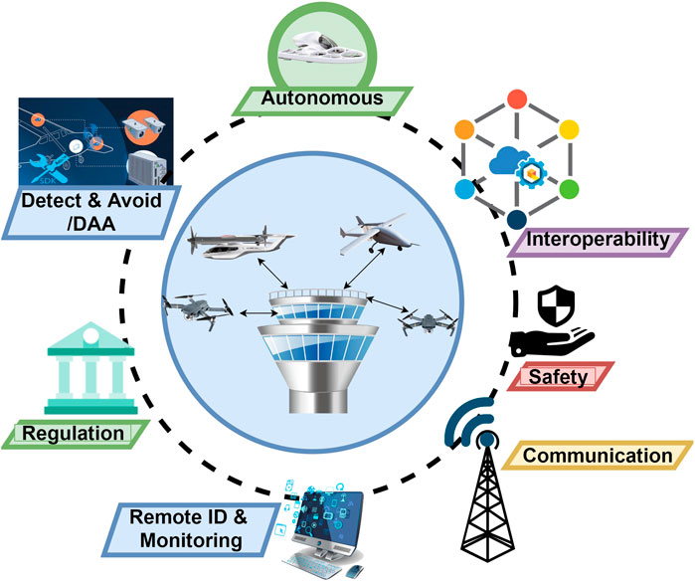

**\*Sensors:\***

- Cameras for video surveillance.

- Inductive loop detectors embedded in road surfaces.

- Radar or lidar sensors for speed detection.

**\*Communication Infrastructure:\***

- Network connectivity for data transmission.

- Wireless or wired communication systems.

**\*Data Processing Units:\***

- Computers or servers to process and analyze collected data.

- Algorithms for traffic pattern recognition and analysis.

**\*Central Control System:\***

- Centralized software for managing and coordinating traffic data.

- User interface for monitoring and control.

**\*Database:\***

- Storage for historical and real-time traffic data.

- Enables trend analysis and reporting.

**\*Traffic Management Software:\***

- Applications for controlling traffic signals and managing congestion.

- Integration with other intelligent transportation systems.

**\*Power Supply:\***

- Reliable power sources for continuous operation.

**\*User Interface:\***

- Display systems for operators to visualize data.

- Control interfaces for manual intervention if needed.

**\*Algorithms and Analytics:\***

- Intelligent algorithms for traffic prediction, optimization, and anomaly detection.

**\*Integration with Other Systems:\***

- Coordination with emergency services, public transportation, or smart city infrastructure.

**\*Maintenance and Diagnostics:\***

- Systems for monitoring the health of components and predicting